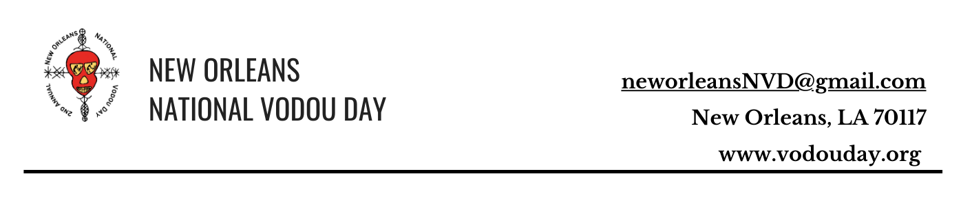

**Art Gallery Submission Criteria - Symposium**

**New Orleans National Vodou Day**

**April 5 & 6, 2025**

**Symposium- April 5, 2025**

**Location TBD**

**Artists Art Gallery Submission Symposium Criteria**

*Please complete the required proposal information for local artists.*

*Send the required information to:* ***neworleansNVD@gmail.com.***

**1. Bio:** Provide a short biography (100-150 words) highlighting relevant experience and

background relevant to your Artist Statement about the Vodou as an elemental force of

change and healing:

**2. Contact Information:**

Insert your name:

Phone number:

Your current photo:

Title of work submitted:

Email address:

Website links:

Your Social Media Method(s):

Mailing Address:

**3. Possible drop-off times of artwork**

**4. Possible pick up times of artwork**

**5. Submission Deadline : December 31, 2024**

**ATTENTION:** All Accepted artwork must be ready for display and meet gallery standards for presentation. (See the display standards that are on the first page). The criteria requirements are perfectly related to the core of Vodou practice and its demonstrating how the results are beneficial to creating a positive world culture.

**Theme:** The artwork should explore Vodou as an elemental force of change and healing. Submissions should reflect the transformative and restorative aspects of Vodou, showcasing its cultural and spiritual significance.

**Size Limitation:** Only small to medium-sized pieces will be accepted. Specifically, dimensions should not exceed 24 inches in any direction.

**Eligibility:** Submissions are open to local artists only. Due to shipping constraints, we are unable to accept submissions from outside the immediate area.

**Submission Requirements:**

**1. Artwork:** *Pieces must adhere to the size limitation and thematic focus.*

**2. Digital Images:** *Submit high-resolution images of the artwork (at least 300 DPI) for initial review.*

**3. Artist Statement:** *Include a brief statement (150-200 words) explaining how the artwork relates to the theme of Vodou as an elemental force of change and healing.*

**Submission Deadline:** December 31st 2024

**Submission Method:** Please email submissions to neworleansNVD@gmail.com

*Note: All accepted artwork must be ready for display and meet gallery standards for presentation.*